**People’s Democratic Republic of Algeria**

**Mohammed Takfi Middle School**

**Level : 3MS Timing : 1h**

Third Term Test

**Text:**

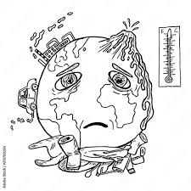 Pollution is anything that makes the earth dirty and unhealthy. Land, air and water are all affected by pollution. **It** takes up space on our land. Many of the things people use every day come in packages like food, games, school supplies and electronics. These packages end up in large underground dumps called landfills. Landfills make land unhealthy for animals and people.

Pollution is in the air we breathe. Trucks, cars and school buses generate toxic smokes from their engines. Water gets polluted with cleaners, paints and chemicals. All of the pollution must be removed from our water before we can drink it. Dumping chemicals into the ocean can hurt sea creatures. This affects human beings, too. People can get sick when they eat the poisoned fish. Loose garbage takes away from the natural beauty of the earth. When trash is not put away, people and animals get exposed to things that could hurt **them**, like broken glass and harmful chemicals.

**Part one**

**A/Reading Comprehension**

Activity 01: Read the text and say ‘True’, ‘False’ or ‘Not mentioned’ (03pts)

1. Pollution makes the earth dirty. (…………………….)
2. Two birds die every single minute before of pollution. (……………………..)
3. Animals and people are in danger because of pollution. (……………………..)

Activity 02: Read the text again and answer the questions (02pts)

1. How can water be polluted ?

………………………………………………………………….

1. What or who do the underlined words in the text refer to:

**It** 🡺 …………………………..  **Them 🡺** ...........................................

Activity 03: Match each word with its synonym (02pts)

Endangered - - Community

Society - - Risks

Effects - - Threatened

Dangers - - Results

**B/Mastery of Language**

Activity 01: Correct the following comparatives (02pts)

1. Air pollution is badder soil pollution because people will not breathe well.

……………………………………………………………………………..

1. Clean parks is beautifuler than polluted parks.

…………………………………………………………………………….

Activity 02: Fill in the gaps with ‘Since’ or ‘For’ (03pts)

1. Green Peace organization has been actively protecting the environment ……………….1971.
2. Salim has been an ecologist ……………….2020.
3. He has worked there ………………………..five years.

Activity 03: Classify the words according to the pronunciation of their final ‘-ed’: (02pts)

Visited - Moved - Finished - Blamed

|  |  |  |
| --- | --- | --- |
| **/ t /** | **/ d /** | **/ id /** |
| **-** | **-**  **-** | **-** |

**Part two**

Situation of Integration: (06pts)

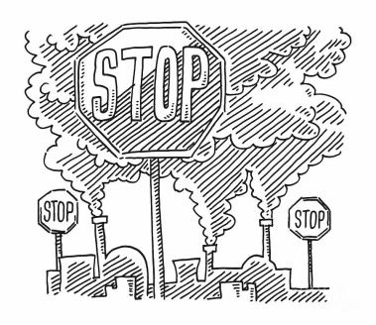 Pollution occurs when ecosystems cannot get rid of substances introduced into the environment. It affects nature, plants, human and even animals. Write a short paragraph about pollution.

Write about:

Definition of pollution

Types of pollution (land, air, water)

Causes of pollution (littering, smokes, rubbish, ….etc)

Solutions (Put your litter in bins, Be responsible, Follow the rules, Use reusable bags …etc)

****Use: must / mustn't / should / shouldn’t / imperative.………………………………………………………………………………………………………………………………………………………………………………………………………………………………………………………………………………………………………………………………………………………………………………………………………………………………………………………………………………………………………………………………………………………………………………………………………………………………………………………………………………………………………………………………………………………………………………………………………………………………………………………………………………………………………………………………………………………………………………………………………………………………………………………………………………………………………………………………………………………………………………………………………………………………………………………………………………………………………………………………

Good Luck